# Method and Material

## Participants

A total of 46 healthy adults participated in our study. 4 participants (2 Males and 2 females of different nationalities, 30±5, mean±SD) worked as models for the capture of human arm motion data. 42 participants (20 Males and 22 females of several nationalities, 25.9±4.35, mean±SD, min. age 20, max. age 39), were participated as ‘co-workers’ in our main experiment. 3 out of 46 participants were left-handed according to the *Edinburgh Handedness Inventory,* and all participants had normal or corrected to normal vision. The experiments were approved by the local ethics committee at the National Institute of Advanced Industrial Science and Technology (AIST) in Tsukuba, Japan, and all participants read and signed an informed consent form before taking part in the experiments. Participants were naïve to the motives of the experiments and received 2021 JPY (Japanese yen) to participate.

## Setup

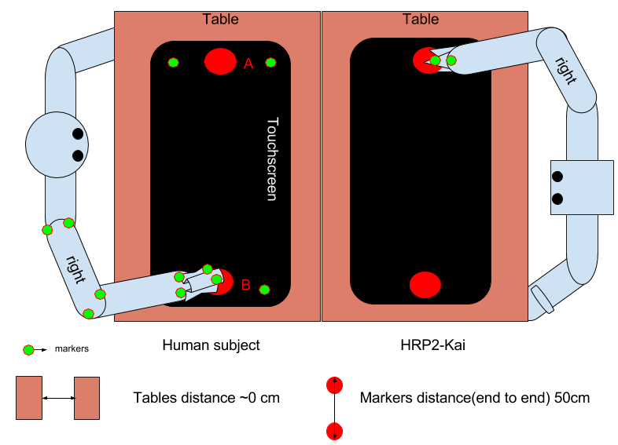The experiments were carried out inside the Joint robotics laboratory at AIST. The participant and co-worker (either a humanoid robot, or a human) were seated on a chair with tables facing each other (Fig. 2).

A 23-inch DELL touch monitor P2314T, Full HD 1920 x 1080 at 60 Hz, response time: 8ms (typical, gray to gray) was placed horizontally on the table in front of the participants and it was used to record participant’s movement positions using MATLAB (9.2, R2017a) running on PC Alienware 17 R3. Two red circles (diameter 5 cm) were presented on the screen, which the participants touched repeatedly (see sub-section *Experimental task and conditions*). A black cardboard (size similar to the touchscreen) with two red circles (diameter 9 cm) was fixed on the table of the co-workers. This setup was enclosed by panels, such that the participants could see only the experiment setup (Fig. 3). The wall behind the co-worker (human/humanoid) was covered with a dark grey curtain.

Fig. 2. Setup

A person standing in a room

Description generated with high confidenceA *Motion Analysis* Motion Tracking System with 6 infrared cameras (kestrel) were used to record the arm motions of the participants and co-workers at a sampling frequency of 200Hz. In total, 14 passives-infrared markers (diameter 13 mm) were used (Fig. 2. Setup). 7 markers were attached on the participant’s right arm (2 on shoulder, 2 on elbow, 2 on wrist and 1 was attached on the right hand’s distal phalanx bone of index finger). 1 marker was attached on the right hand’s (gripper of robot co-worker or distal phalanx bone of index finger of human co-worker). One marker each was attached on top of participant’s and co-worker’s stylus and the last 4 markers were fixed to the participant’s table. Two styluses, of lengths (13 cm, 23 cm) and diameters (38 cm and 52cm) were provided to the human and robot co-worker respectively.

Figure 3. Experiment Setup with Mocap

A bipedal HRP2-Kai humanoid robot (154cm tall, 58kg, 32 DOF) was used as the robot co-worker (Fig. 4), robot’s right arm (7 DOF) was used during the task. During sessions with *human as co-worker* a trained experimenter (male, 37) acted as human co-worker. He was previously trained to make movements at several htp.

#### **Experimental task and conditions**

Fig. 1. Robot as co-worker

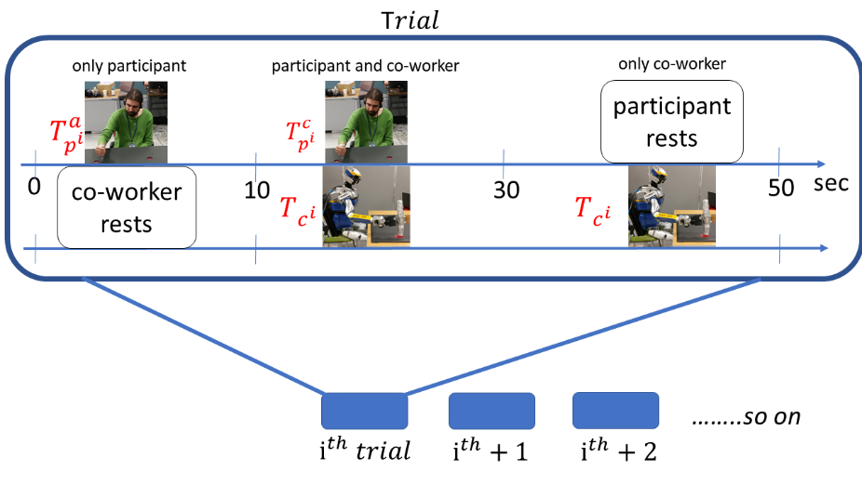Motivated by the hand movements during an industrial pick and place, or parts assembly task, our task required participants to sit comfortably on a chair and repeatedly press two static red circles (A and B in fig 2) on a table with a stylus in right hand (See Fig. 3). A co-worker, who was either a human or a humanoid robot worked on the same task in front of the participants. Prior to the experiment, participants were given earbuds and headphones to mitigate influence from external sound (especially robot’s joint noise), they were strongly requested to wear it throughout the experiment except during break time. Every participant was instructed to “*always* *hold the stylus like a stamp* and *touch alternatively inside each red circle on touchscreen while making their hand movements comfortably smooth and continuous*”. They were specifically told to “*focus on your own task and ignore the co-worker when it starts after them*”. No instructions were given on the speed of the movements and how to do it. Little ~30 seconds breaks were given after every trial and next trial started only when participant was not tired, though none of the participant took more than 30 seconds break between each trial in a session. Long break of 3~5 minutes were given between each session.

Fig. 4. ith Trial

We studied six experimental conditions. In four of the conditions, specifically *robot co-worker*(**RV**)*, robot covered co-worker*(**RC**)*, robot non-biol*(**RN**)and *robot indus*(**RI**)*,* the participants worked with a robot co-worker. In the remaining *human co-worker*(**HV**) and *human covered co-worker*(**HC**) conditions, they worked with a human co-worker. The robot played back the recorded movement of human models in the *robot co-worker, robot covered co-worker*. The robot movements in the *robot non-biol* and *robot-indus* were ‘non-human’. The robot movements in the *robot non-biol* condition are explained in section (*robot movement trajectories*) while the movements in the *robot indus* are not presented in this paper.

Each condition had 10 trials. In each trial (Fig. 4), participants worked for 50 seconds with a co-worker. They initially perform alone for 10 seconds, performed with the co-worker for the next 20 seconds, and relaxed while watching the co-worker perform its/his task for the last 20 seconds. The co-worker performed at a constant, unique pseudo-randomly selected frequency (in the range of 0.16 to 1.1 Hz) in each trial. We quantified the participant performance in the trials by their half time periods or htp (the average time between two touches) measured using motion tracking (Motion Analysis Corp.) and examined how the participants htps changed with respect to the co-worker htps. In the *Human* as co-worker (*Human co-worker* and *Human Covered co-worker*) conditions, experimenter was kept informed about the frequency of the movement in each trial using a headphone, which he wore throughout the experiment and it was connected to the same PC where a rhythmic “beep” were generated using MATLAB as done by *Bisio et al*. (*9*), though in our experiment, “beep” started 10th second after participant’s 1st touch on the touchscreen and remain until the end of the trail. While in the robot as co-worker (*Robot-co-worker, Robot Covered-co-worker, Robot-non-biol and Robot-indus*) conditions, robot co-worker also started 10th second after participant’s 1st touch on the touchscreen and remain until the end of the trail.

The participants were randomly assigned to one of the 7 groups. Each group worked in three sessions. All the groups worked in a robot-co-worker condition, while the other two conditions differed between the groups (see Table 1). The order of the conditions was randomized across participants in each group.

|  |  |  |  |  |  |  |  |
| --- | --- | --- | --- | --- | --- | --- | --- |
| Groups | G1 | G2 | G3 | G4 | G5 | G6 | G7 |
| Session 1 | *robot-co-worker* | | | | | | |
| Session 2 | *robot-indus* | *robot covered co-worker* | *human co-worker* | *robot covered co-worker* | *human co-worker* | *robot covered co-worker* | *robot covered co-worker* |
| Session 3 | *robot non-biol* | *robot-indus* | *human covered co-worker* | *human covered co-worker* | *robot non-biol* | *human co-worker* | *robot non-biol* |

Table 1. Experimental Groups

#### **Robot movement trajectories**

*The robot arm movement in the Robot-co-worker* and *Robot-covered-co-worker* conditions were a playback of the human arm movements recorded using motion tracking system. We recorded human movements (cued by audio cues) at 0.5Hz, 0.83Hz, 1.3Hz, 1.6Hz and designed the robot movements for the frequencies (1.1Hz, 1Hz, 0.72Hz, 0.63Hz, 0.55Hz, 0.33Hz, 0.25Hz, 0.17Hz) by using the following interpolation,

Hz

Hz

In the range of < <

Desired curve, For i = 1:N, do

|  |  |  |
| --- | --- | --- |
|  |  | (1) |

End For loop,

Where, N is the sample size required to cover 50 cm distance (between onset-end movement) at respective htps,

, = lower and upper frequency bounds for interpolation,

= desired interpolation frequency,

,, are curve co-ordinates at frequencies , , , respectively,

and in case of extrapolation == ) > .

Well learnt human movements are characterized by a bell-shaped velocity profile. The peak of the bell-shaped profile may be shifted forward in time when precision is required at the reach end (like in our task when the participants required to touch inside a given target region), but the velocity profile is normally characterized by a single peak. Therefore, here we used a trajectory with three distinct velocity peaks (Fig. 5. C, D) as a candidate ‘non-biological’ movement profile in the **RN** conditions. Since our task is inspired by the hand movements during an industrial pick-n-place task, to have a smooth transition, we chose to design *robot non-biol as* piecewise polynomial trajectory by fusing a 5th and 3rd order polynomials divided into three segments (*lift-off*(l)*, carry*(c)*, set-down*(s)) [1]. In (Fig. 5) initial () and final () time instants, , and are the time crossing at via-point 1 and via-point 2 respectively. We restricted our task movements in YZ plane therefore, the piecewise polynomial trajectory was mainly design in y(horizontal) & z(vertical) direction while x was always kept constant zero.

In movement direction (Y-axis), for 5-5-5 order piecewise trajectory, total of 18 parameters were computed,

|  |  |  |
| --- | --- | --- |
|  |  | (1) |

|  |  |  |
| --- | --- | --- |
|  |  | (2) |

|  |  |  |
| --- | --- | --- |
|  |  | (3) |

Boundary conditions would be given by

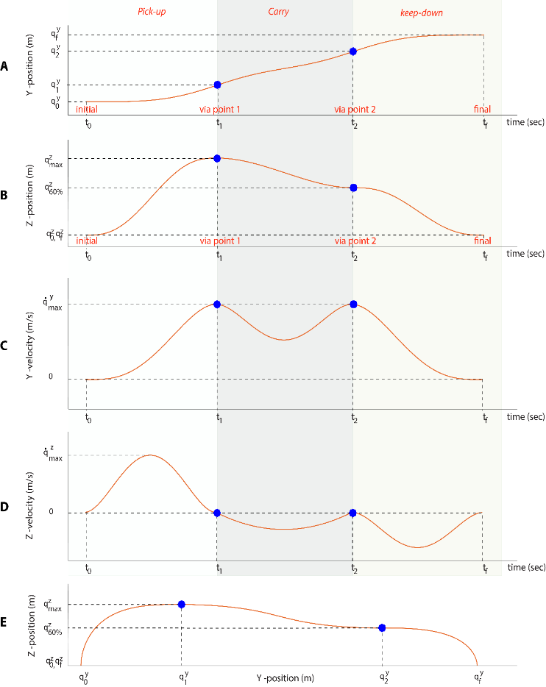

Figure 5. In YZ plane, Positions of Robot-non-biol ‘5-3-5’ (pick-up(p), carry(c), keep-down(k)) trajectory, blue circles represent via- points

*4 crossing conditions,*

*6 initial and final conditions*

*6 continuity conditions for velocity, acceleration and jerk*

= (*tuning parameter*)

= (*tuning parameter*)

Where, , to maintain shape of trajectory, desirable to be played on HRP2-kai,

using above boundary conditions, we calculated the parameters in (Eq. 1, 2, 3)

*During Lift-off (l)*

*During Carry (c)*

*During Set-down (s)*

In direction perpendicular to movement direction (Z-axis), for 5-3-5 order piecewise trajectory, total of 16 parameters were computed,

|  |  |  |
| --- | --- | --- |
|  |  | (4) |

|  |  |  |
| --- | --- | --- |
|  |  | (5) |

|  |  |  |
| --- | --- | --- |
|  |  | (6) |

Boundary conditions would be given by,

*4 crossing conditions,*

*6 initial and final conditions*

*4 continuity conditions for velocity and acceleration*

Where, is 60% of ,

using above boundary conditions, we calculated the parameters in (Eq. 4, 5, 6)

*During Lift-off (l)*

*During Carry (c)*

*During Set-down (s)*

Inspired by trapezoidal shape trajectories of industrial manipulators in *pick and place* task, we designedmodified smooth trapezoidal trajectory with two via-points, *Robot-indus* as 3rd order piecewise polynomial trajectory divided into 3 segments (*pick-up*(p)*, carry*(c)*, keep-down*(k)),

In (Fig. 6) and are initial and final time instants, , and are the time crossing at via point 1 and via point 2 respectively. We restricted our task movements in YZ plane therefore, the piecewise polynomial trajectory was mainly design in y(horizontal) & z(vertical) direction while x was always kept constant zero.

In movement direction (Y-axis), for 3-3-3 order piecewise trajectory, we need to compute total 12 parameters,

|  |  |  |
| --- | --- | --- |
|  |  | (8) |

|  |  |  |
| --- | --- | --- |
|  |  | (9) |

|  |  |  |
| --- | --- | --- |
|  |  | (10) |

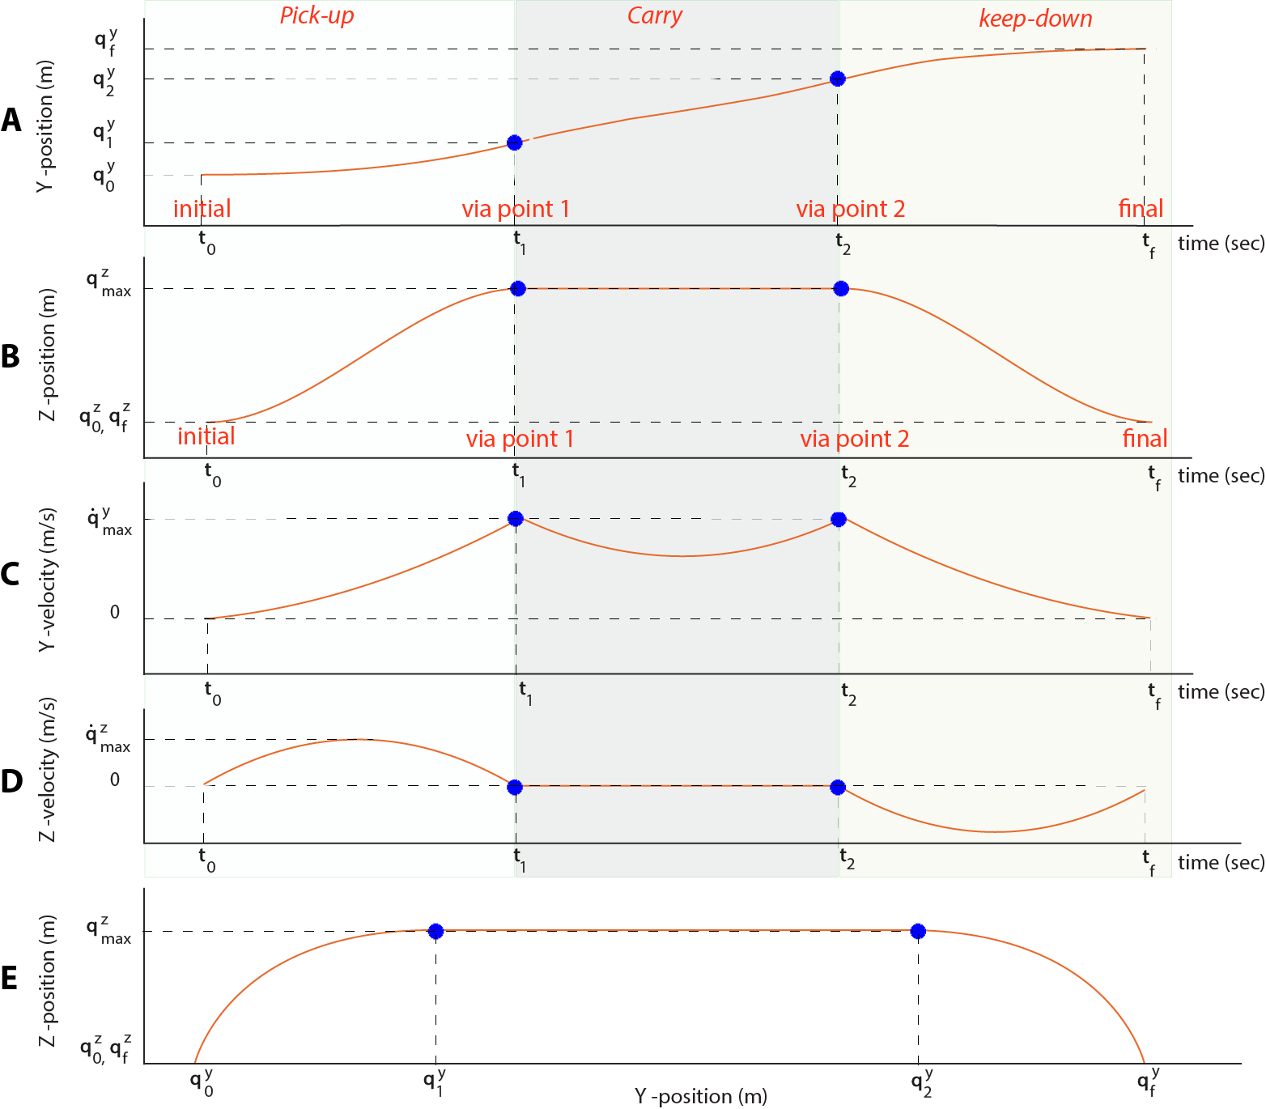Boundary conditions would be given by

Figure 6. In YZ plane, Positions of Robot-indus ‘3-3-3’ (pick-up(p), carry(c), keep-down(k)) trajectory, blue circles represent via- points

*4 crossing conditions,*

*4 initial and final conditions*

*4 continuity conditions for velocity and acceleration*

= (*tuning parameter*)

= (*tuning parameter*)

Where, , to maintain shape of trajectory, desirable to be played on HRP2-kai,

using above boundary conditions, we can calculate the parameters (in Eq. 8,9,10)

*During Pick-up (p)*

*During Carry (c)*

*During Keep-down (k)*

Again, in direction perpendicular to movement direction (Z-axis), for 3-3-3 order piecewise trajectory, we need to compute total 12 parameters,

|  |  |  |
| --- | --- | --- |
|  |  | (11) |

|  |  |  |
| --- | --- | --- |
|  |  | (12) |

|  |  |  |
| --- | --- | --- |
|  |  | (13) |

Boundary conditions would be given by,

*4 crossing conditions,*

*4 initial and final conditions*

*4 continuity conditions for velocity and acceleration*

=

using above boundary conditions, we can calculate the parameters (in Eq. 11, 12, 13)

*During Pick-up (p)*

*During Carry (c)*

*During Keep-down (k)*

#### Playing on the HRP2



Cartesian tracker used in generating the arm movements of the humanoid robot.

Motor interference between Humans and Humanoid robots effect of biological and artificial motions

### *htp* analysis

Our further analysis is based on the position data of both participant’s and co-worker’s stylus markers, measured using motion tracking system (*Motion Analysis*, Kestrel).

The participant behaviors were quantified by their *half time periods* or *htp* (the average time between two touches).

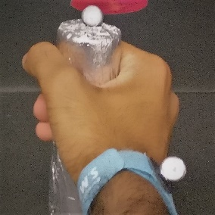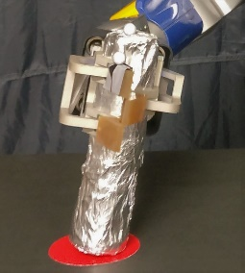

Since our movements were oriented in the YZ plane of camera, where height of movement measured in Z direction and length of movement measured in Y direction. In a trial, to find the movement *htp*, we looked for the change in the direction of the movement velocity (y-direction) and outline the onset-end of the movements to extract individual iterations (movement between two red circles A&B was considered as single iteration, Fig. 2), later *htp* is defined as the average of iterations movement duration.

Fig. 7. stylus marker

The trials were divided into 3 blocks (See Fig. 4), the first 10 seconds when participants performed alone Tp*a*, next 20 seconds when they performed with the co-worker Tp*c*, and in the last 20 seconds they relaxed while watching the co-worker perform its/his task Tc, where Tp*a* represents the participant htp when performed alone; Tp*c*, htp when the participant performed with co-worker; Tc htp of the co-worker. To examine how the participants htps changed with respect to the co-worker htps. Specifically, we analyzed (*Tp*c - Tp*a*) vs (Tc – Av(Tp*a*)), where Av(Tp*a*), the average undisturbed htp across trials. Since the co-worker’s htp was random across trials, therefore participant’s htps were arranged in increasing order w.r.t. coworker’s htp on the abscissa. To find out how much contagion has induced, this relation was regressed with either a first or second order polynomial. To fit the data, we used MATLAB’s *fitlm* function to create linear regression model using following arguments (see Eq. 14). The regression model was chosen based on Akaike Information criteria (AIC) with lowest value *(2)*.

|  |  |  |
| --- | --- | --- |
|  |  | (14) |

Figures (8, 9, 10, 11, 12) show examples of data regressed and fitted either with linear or quadratic model using MATLAB’s *fitlm* function for conditions *robot-covered-co-worker, human-co-worker, human-covered-co-worker, robot-non-biol-co-worker and robot-indus-co-worker* respectively. Notice that in all conditions *htp* was random across trials and the data displayed in figures are an ensemble of the participant behaviors arranged in increasing *htp* on the abscissa.

The slopes of the tangent on the starting point (Tc =0.45 for *robot co-worker, human co-worker, robot covered co-worker* and *human covered co-worker* conditions; Tc = 0.75 for *robot non-biol* and *robot indus* conditions) of regression models were considered as criteria to measure induced contagion. The positive slopes (Fig. 8 to 12) show that the co-worker’s behavior *htp* influenced the participant’s htp, while zero slopes mean no contagion and negative slope mean contagion noise.

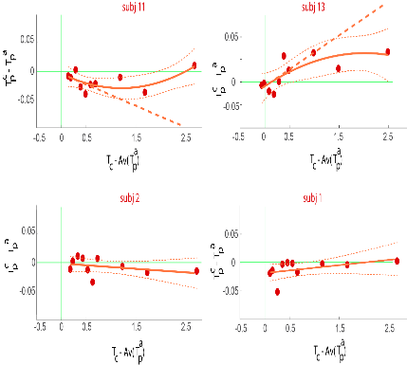

Figure 10. Human covered co-worker condition

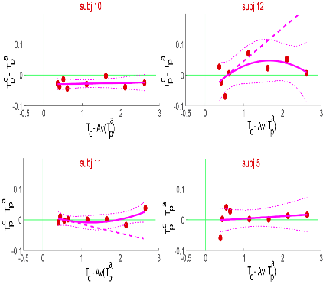

Figure 11. Robot non-biol condition

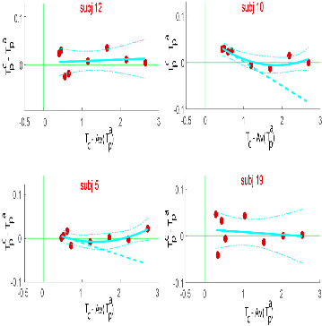

Figure 12. Robot non-biol condition

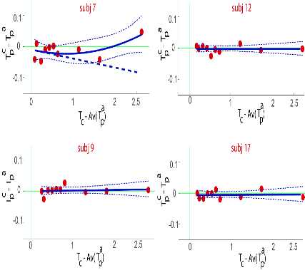

Figure 8. Robot covered co-worker condition

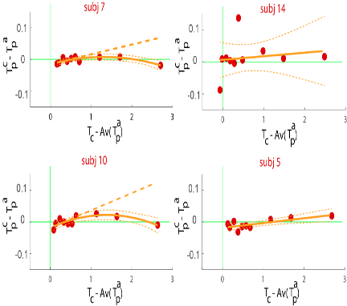

Figure 9. Human co-worker condition

Specially in the *robot co-worker* and *human co-worker* conditions the participants htps increased when the co-workers htps were longer (1st quadrant, Fig. 1B, Fig. 8), but this related increase in htps had a threshold after which the participants htps decreased. Using AIC, we found second order fit better to explain this behavior with many participants. More importantly, in *robot co-worker* condition participants htps also decreased when the co-worker was faster (shorter htps) (3rd quadrant, Fig 1B), signifying that co-worker made the participants frequency higher, hence improvement in performance.

It is also crucial to note that we did not find such modulation trend of contagion with other conditions in which both co-workers (human experimenter, robot HRP2-kai) were covered and when robot co-worker performed non-biol and industrial-inspired movements.

#### Statistical analysis

Condition wise, participants slope distribution were checked for normalization using Shapiro-Wilk test (p<0.05, normally distributed) and later gauged to determine the significance of slopes across the participants using T-test or Signed Rank test.

In robot co-worker condition the slope distribution was highly significant and positive across participants (median = 0.017, Z (38) = 3.70, p = 0.0002), we also found same result in human co-coworker condition where slope distribution was highly significant and positive across participants (median = 0.014, Z (12) = ~, p = 0.002), moreover, this third quadrant results (Fig 1B, fig HC) as an *improvement* in participant performance induced by the presence of the human as well as a robot co-worker because, the participant movement frequency increased (relative to their performance frequency alone).

Note that we did not find any significant effect when both robot and human co-worker body except right arm was covered in robot-covered-co-worker (mean±SD, -0.003±0.009) (T(16) = -0.3, p = 0.78) and human-covered-co-worker conditions (mean±SD, 0.004±0.02) (T(12) = 0.24, p = 0.82), also when robot movements violated biological laws of motion such as here in robot-non-biol (median = -0.006, Z (16) = -1.07, p = 0.29) and robot-indus (median = 0.0003, Z(17) = -0.3, p = 0.78) conditions. These results support our hypothesis that the humanoid form as well as biological motion are required for induction of the contagion. It is also interesting to highlight while these above conditions failed to induce contagion in the participants performance, we also found slopes difference between our main condition robot-co-worker and other conditions significant *(Bonferonni corrected)*. Condition wise, 4 T-test was performed on the slope difference between **RV vs RC** (mean±SD, 0.04±0.015) (T(16) = 2.74, p = 0.028)**, RV vs HC** (mean±SD, 0.024±0.01) (T(12) = 2.50, p = 0.05)**, RV vs RN** (mean±SD, 0.031±0.013) (T(16) = 2.32, p = 0.07)**, RV vs RI** (mean±SD, 0.05±0.02) (T(17) = 2.53, p =0.04). Another T-test was performed on the slopes difference of robot co-worker **RV**, and corresponding participants human co-worker **HV**, **RV vs** **HV**, (T(12) = 0.50, p = 1.24; light orange data in Fig 1D). This result strengthens our hypothesis that humanoid appearance robot can in fact induce contagion and improve human performance, but only when generated movements obey biological laws.

Since our majority of slopes distribution were non-parametric therefore, one-way Kruskal-Wallis H test was also performed on the regression model slopes distribution of conditions and found significant difference between conditions (H(4), P = 0.009)*.*

Notice that initially we recruited 35 participants (inclusive 3 outliers, 95% C.I.), all of whom performed in the *robot co-worker* condition, with 13 participants performing each of the *robot covered co-worker, human co-worker, human covered co-worker, robot non-biol, and robot-indus* conditions. Since statistically we found highly significant positive effect of *htp* across the participants in *robot co-worker* condition, we believed that this effect should also be there when considered *robot co-worker* slope distribution respectively across other conditions. However, we failed to see same effect across *robot covered co-worker robot non-biol* )*, and robot indus* )*,* conditions therefore, we later added 7 more participants in *robot covered co-worker* and *robot non-biol* conditions (see Table 1(G7)) to get statistically significant effect in *robot co-worker across rest conditions.* Later group wise another one-way Kruskal-Wallis H test was performed to check whether our main condition robot co-worker across participants varied between conditions, as expected no significant difference was found between , ,, , (H(3), P = 0.99) where RV is robot co-worker condition grouped with (*human co-worker, robot covered co-worker, human covered co-worker* and *robot non-biol*) conditions respectively (see Table 1 for more details).

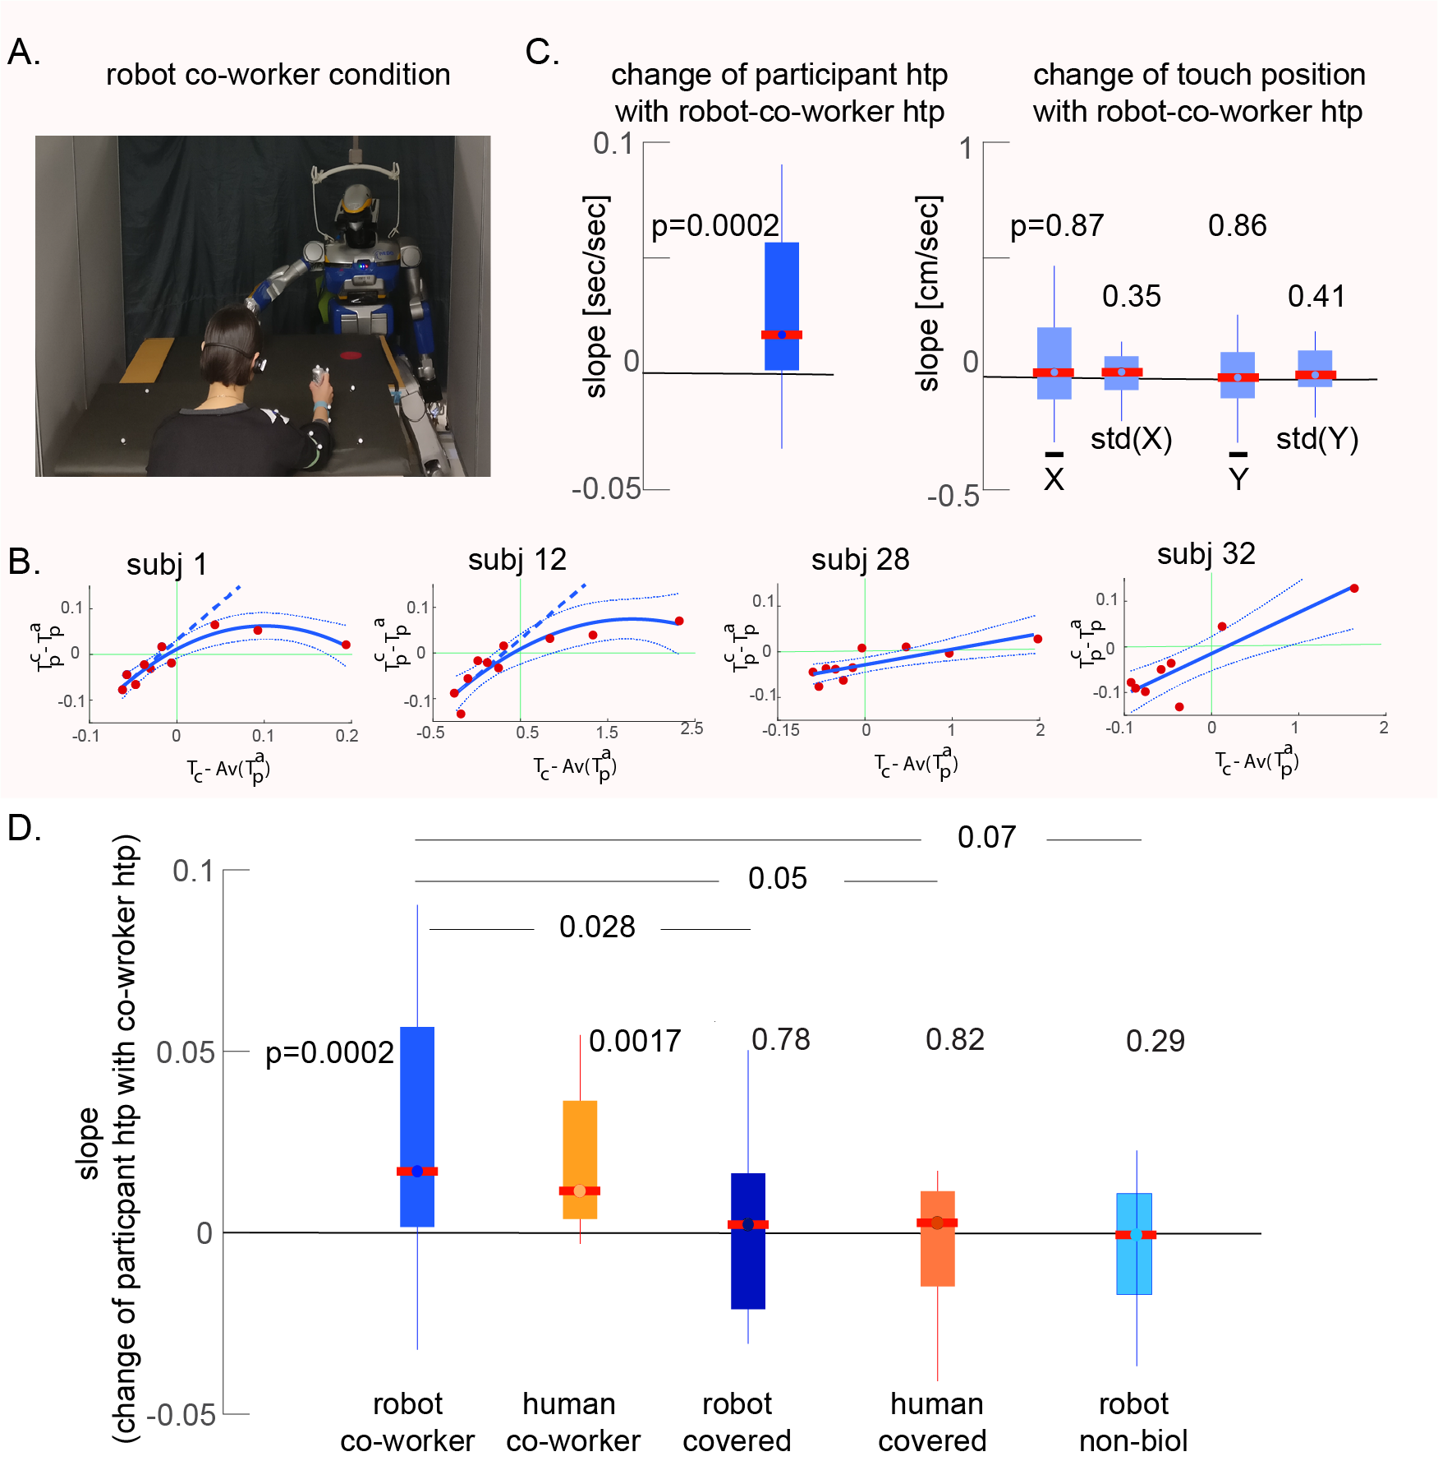It is often possible to achieve increase in performance at a cost of increase in movement variance. To measure how much participant’s touch position varied in each trial, we recorded participants touch positions (X, Y coordinates inside red circles) using MATLAB ‘ginput’ function. Since touchscreen was rectangular (51cm x 29cm), the circles were placed diagonally such that their center distance would not exceed 50 cm. It is worth mentioning, while the participants performance was affected (frequency increased) when they worked with robot-co-worker, no such trend was observed in the participants touch behavior, the participant maintained the same touch positions () (Fig. 13) variance () between when they worked alone and when they worked with the robot co-worker, showing that the robot did not affect their task accuracies. In order words with the increase in performance we found no visible effect on their movement accuracy.

Figure 13. slope (standard error of mean)

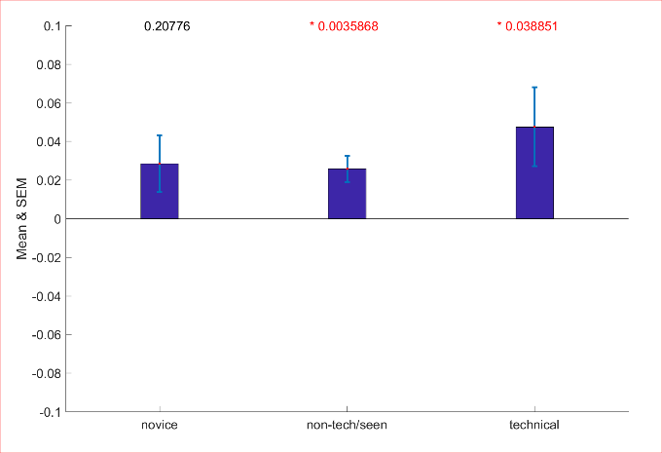 In *Robot-co-worker condition,* we divided our total participants population (N = 39) into three groups (G1 = person from technical background, G2 = person with prior basic knowledge of robots, they may have seen in shops or museums or participated before in some HRI experiments, G3 = novice, naive) with sample sizes (N1 = 13, N2 = 11, N3 = 15) based on their level of technical experience in the domain of science and engineering. Interestingly within our participants, the effect was observed to be stronger in participants with robot experience, compared to those without (Supp. Fig, XXX), suggesting that the effect we show does not reduce with robot experience (novice/naïve (G3; Z(14) = ~, p = .20) < non-tech (G2; T(10) = 3.8, p = 0.004) < technical (G1; T(12) = 2.3, p = 0.04)). KRUSWILIS (H(2), P = 0.424)

Figure 2. updated

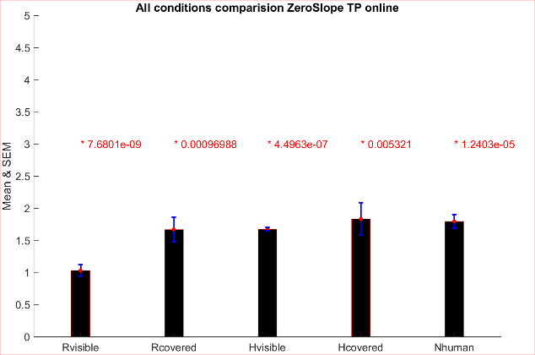 Since slopes of the tangent on the starting point (i)] of regression models were considered as criteria to measure induced contagion but in many participants this related increase in *htp*s had a threshold after which the participants *htp*s decreased and one could argue here the significance of using 2nd order polynomial regression model irrespective of AIC therefore, we were interested to find that particular threshold of ‘zero slope’ on the 2nd order regression model, where tangent becomes parallel to abscissa. In order words, zero crossing first derivative of regression model. The point on abscissa at which the direction of slope changes from positive to negative. Statistically, in each condition, we found out the points to be above 1 second, which is above 70% of total played frequencies by co-workers (Fig.)..

### kinematic analysis

Likewise in section *‘htp analysis’* where we dealt with *htp,* here we used same procedure for all 6 conditions (*robot co-worker, human co-worker, robot covered co-worker, human covered co-worker*, *robot non-biol* and *robot indus* conditions) on the kinematic parameters (**K**) of the participant’s movement between touches (maximum movement length, maximum movement height, maximum absolute movement velocities, mean absolute movement velocities , minimum movement accelerations, maximum movement accelerations ) to find out, whether these parameters have contributed in the induced motor contagion.

|  |  |  |
| --- | --- | --- |
|  |  | (15) |

To examine how the participants kinematic parameters *Kp*c (Eq. 15) have changed with respect to the co-worker kinematic parameters *Kc*. Specifically again, we analyzed (*Kpc - Kpa*) vs (*Kc – Av(Kpa)*), where *Av*(*Kpa*), the average undisturbed **K** across trials. Since the co-worker’s htp was random across trials, therefore both participant’s and co-worker’s **K** were arranged in increasing order w.r.t. coworker’s htp on the abscissa. To find out how much contagion has induced, these relations of respective kinematic parameter were regressed with either a first or second order polynomial. To fit the data, we used MATLAB’s *fitlm* function to create linear regression model using following arguments (see Eq. 14). The regression model was chosen based on Akaike Information criteria (AIC) with lowest value *(2)*. The slopes of the tangent on the starting point of regression models were considered as criteria to measure induced contagion.

#### Statistical analysis

In *robot co-worker* condition, we only found statistically significant and positive effect of maximum acceleration , the slope distribution was not normal across the participants (p<0.05, Shapiro-Wilk test, median = 0.018) (Z(38)=1.95, p = 0.05). Interestingly, in *human co-worker* condition,we found statistically significant positive effect of movement maximum velocity , (p<0.05, Shapiro-Wilk test, median = 0.20) (Z(12)=~, p = 0.03) and statistically significant negative effect of movement mean velocity , (p<0.05, Shapiro-Wilk test, median = -0.45) (Z(12)=~, p = 0.022), the slope distributions were not normal across the participants in both cases. Our findings did not reveal effect of kinematic parameters in rest of the conditions.

## Questionnaire

Since in our experiment, we believed that making the robot’s performance frequency higher (htp shorter) led to an increase in participants performance frequency (decrease in htp) without them consciously perceiving it. To verify our statement that this change in behavior (improve in performance) of participants is implicit and in no way explicit, in Experiment 2, a short questionnaire was designed to understand the state of mind of the participants and if they were aware of the effect induced by the co-worker during experiment.A screenshot of a video game

Description generated with high confidence Following questions were prepared for each session and participants had to choose their most plausible answer on a scale of 0 to 7, where 0 (Not at all), 7 (very strongly)

1. My movements were affected when the agent was working with me.
2. My movement speed was changed when the agent was working with me.
3. I was tired during the experiment.
4. I could maintain the movement speed that I wanted even when the robot was performing its task.
5. I found it difficult to do my task when the agent was working with me.

We took average of question 1, 2 and 4, as they meant to convey same meaning which is if participants felt their behavior was influenced by the co-worker. Question 3, also ruled out the possibility which one could argue that their decrease in performance as co-worker’s htp gets longer may be because of being tired during the experiment. (fig xx) show (mean±SD) of questions answered by participants. Which clearly favors our belief that their increase in performance happened implicitly.

# References

1. L. Biagiotti, C. Melchiorri, *Trajectory planning for automatic machines and robots* (Springer Berlin Heidelberg, 2009).
2. H. Akaike, Information theory and an extensión of the maximum likelihood principle. International symposium on information theory, 267–281 (1973).